Chapter
4

Math Services
The application services layer math services provides low level mathematical functionality required by engineering software. This package provides services for single variable, single value functions, numerical analysis services for root finding and linear algebra services for matrix and vector mathematics.

Functions
Yadda, yadda, yadda

Requirements

Logical Design

Static Models
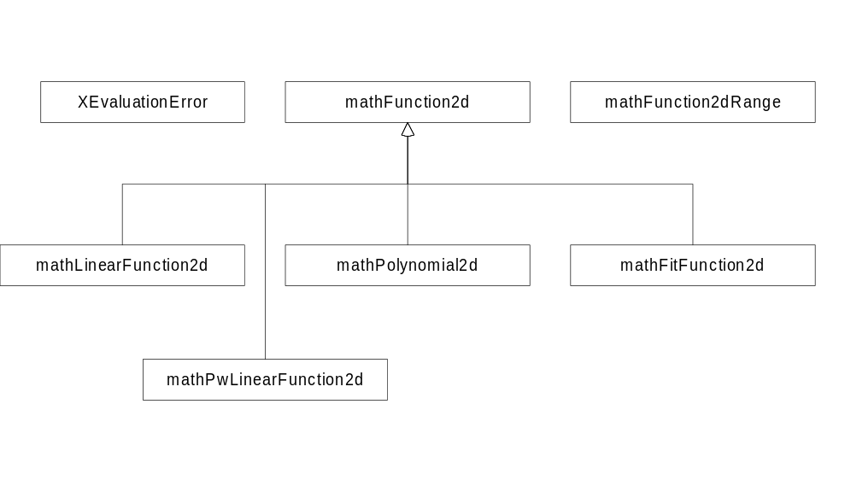

Dynamic Models

Physical Design

Specifications

mathFunction2d
Defines an abstract interface for continuous single variable, single-valued functions.

Public Interface - Member Functions
~mathFunction2d
virtual ~mathFunction2d();
Virtual destructor. Implement with a non-inline method.
Evaluate
virtual Float64 Evaluate(Float64 x) const = 0;
Evaluates the function at x. If an error occurs during the evaluation, throw a mathFunction2d::XEvaluationError exception.
GetRange
virtual math1dRange GetRange() const = 0;
Returns the range over which the function is valid.

math1dRange
Defines a Range in the real (Float64 anyway) domain

Public Interface - Member Functions
math1dRange
math1dRange();
Default constructor. Sets the left and right bounds of the range to zero/Limit.
math1dRange
math1dRange(Float64 leftLocation, BoundType leftBound, Float64 rightLocation, BoundType rightBound);
Constructor
math1dRange
math1dRange(const math1dRange & rOther);
Copy constructor
operator =
math1dRange &
operator=(const math1dRange & rOther);
Assignment operator
GetLeftBoundLocation
Float64 GetLeftBoundLocation() const;
Returns the location of the left bound of the range. This function will assert if the bound type is Infinite.
SetLeftBoundLocation
void SetLeftBoundLoction(Float64 bound);
Sets the left bound of the range.
GetLeftBoundType
math1dRange::BoundType GetLeftBoundType() const;
Returns the type of the left bound of the range.
SetLeftBoundType
void SetLeftBound(math1dRange::BoundType type);
Sets the type of the left bound of the range.
GetRightBoundLocation
Float64 GetRightBoundLocation() const;
Returns the location of the Right bound of the range. This function will assert if the bound type is Infinite.
SetRightBoundLocation
void SetRightBoundLoction(Float64 bound);
Sets the Right bound of the range.
GetRightBoundType
math1dRange::BoundType GetRightBoundType() const;
Returns the type of the Right bound of the range.
SetRightBoundType
void SetRightBound(math1dRange::BoundType type);
Sets the type of the Right bound of the range.
IsNull
bool IsNull() const;
Returns true if the range is the empty set.
SetNull
void SetNull();
Sets the left and right bounds to (0,Infinite).
IsIntersection
bool IsIntersection(const math1dRange& rOther) const;
Returns true if the two ranges overlap
Intersection
math1dRange Intersection(const math1dRange& rOther) const;
Returns the intersection (overlapping part) of the two ranges.
Union
math1dRange Union(const math1dRange& rOther) const;
Returns the union (enclosing boundary) of two ranges. The two ranges do not have to overlap.

IsInRange
bool IsInRange(Float64 value) const;
Returns true if the value is within the range

Public Interface - Enumerations
BoundType
enum BoundType { Bound, // range has defined value at bound location
Limit, // range defined up to, but not at, at this location (eg, Tan(90))
Infinite // range not bounded in this direction };
This enumeration encapsulates all types of range boundaries in the real domain

mathXEvaluationError
Math function evaluation error exception. Thrown from mathFunction2d::Evaluate() if an error occurs.

Public Interface - Member Functions
XEvaluationError
XEvaluationError(mathXEvaluationError::Reason reason,
Float64 location);
Constructor
XEvaluationError
XEvaluationError(const mathXEvaluationError& rOther);
Copy constructor
operator =
mathXEvaluationError&
operator=(const mathXEvaluationError& rOther);
Assignment operator
GetReason
mathXEvaluationError::Reason GetReason() const;
Returns the reason they exception was thrown.
GetLocation
Float64 GetLocation() const;
Returns the location where the function was evaluated.

Public Interface - Enumerations
Reason
enum Reason { Unknown, // evaluation failed for an unknown reason
Undefined, // function is not defined at this location
MultiValued, // function has multiple values at location
PosInfinity, // function evaluation is positive infinity
NegInfinity, // function evaluation is negative infinity
};
This enumeration encapsulates the reasons why a function evaluation could fail.

mathLinearFunction2d
Derived from mathFunction2d, this class represents a linear function of the form f(x) = mx+b.

Public Interface - Member Functions
mathLinearFunction2d
mathLinearFunction2d();
Default constructor. Creates a function whose slope and y-intercept are zero.
mathLinearFunction2d
mathLinearFunction2d(const gp2dPoint& p1, const gp2dPoint& p2);
Constructor. Creates a line using two, non-coincident points.
mathLinearFunction2d
mathLinearFunction2d(Float64 slope, Float64 yIntercept);
Constructor. Creates a line using a slope and a y-intercept.
mathLinearFunction2d
mathLinearFunction2d(const mathLinearFunction2d& rOther);
Copy constructor
~mathLinearFunction2d
~mathLinearFunction2d();
Destructor
operator =
mathLinearFunction2d& operator=(const mathLinearFunction2d& rOther);
Assignment operator.
Evaluate
Float64 Evaluate(Float64 x) const;
Evaluates the function at x.
Reset
void Reset();
void Reset(const gp2dPoint& p1, const gp2dPoint& p2);
void Reset(Float64 slope, Float64 yIntercept);
Resets the function. The first form makes the function a horizontal line at y=0. The second form resets the function using two, non-coincident points. The third form resets the function using a slope and y-intercept.

mathPwLinearFunction2d
Derived from mathFunction2d, this abstract class represents a piecewise linear function.

Public Interface - Member Functions
mathPwLinearFunction2d
mathPwLinearFunction2d();
Default constructor. Creates a function with a range of 0,0 and is undefined for all values.
mathPwLinearFunction2d
mathPwLinearFunction2d(const mathPwLinearFunction2d& rOther);
Copy constructor
~mathPwLinearFunction2d
~mathPwLinearFunction2d();
Destructor
operator =
mathPwLinearFunction2d& operator=(const mathPwLinearFunction2d& rOther);
Assignment operator.
Evaluate
Float64 Evaluate(Float64 x) const=0;
Evaluates the function at x.
GetRange
virtual math1dRange GetRange() const = 0;
Returns the range over which the function is valid.
GetNumPoints
Uint32 GetNumPoints() const=0;
Returns the number of points which define the segments of the function.
GetPoint
gpPoint2d GetPoint(Uint32 pnum) const=0;
Returns the ith point. (zero-based)
GetPoints
std::vector<gpPoint2d> GetPoints() const=0;
Returns all points for the line segments which make up the function.

mathPwLinearFunction2dUsingPoints
Implements mathPwLinearFunction2d using a get/set points interface.

Public Interface - Member Functions
mathPwLinearFunction2dUsingPoints
mathPwLinearFunction2dUsingPoints();
Default constructor. Creates a function with a range of 0,0 and is undefined for all values.
mathPwLinearFunction2dUsingPoints
mathPwLinearFunction2dUsingPoints(std::vector<gpPoint2d> points);
Constructor. Creates a function using the vector of points given.
mathPwLinearFunction2dUsingPoints
mathPwLinearFunction2dUsingPoints(const mathPwLinearFunction2dUsingPoints& rOther);
Copy constructor
~mathPwLinearFunction2dUsingPoints
~mathPwLinearFunction2dUsingPoints();
Destructor
operator =
mathPwLinearFunction2dUsingPoints& operator=(const mathPwLinearFunction2dUsingPoints& rOther);
Assignment operator.
Evaluate
Float64 Evaluate(Float64 x) const;
Evaluates the function at x.
GetRange
virtual math1dRange GetRange() const;
Returns the range over which the function is valid.
GetNumPoints
Uint32 GetNumPoints() const;
Returns the number of points which define the segments of the function.
GetPoint
gpPoint2d GetPoint(Uint32 pnum) const;
Returns the ith point. (zero-based)
GetPoints
std::vector<gpPoint2d> GetPoints() const;
Returns all points for the line segments which make up the function.
SetPoints
void SetPoints(const std::vector<gpPoint2d>& points);
Sets all points which make up the function
AddPoint
void AddPoint(const gpPoint2d& point);
Sets all points which make up the function
Clear
void Clear();
Clears all points.

mathPolynomial2d
Derived from mathFunction2d, this class represents a general polynomial of the form 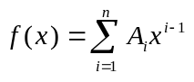.
Implement only if needed.

mathFitFunction2d
Derived from mathFunction2d, this class represents a function that is a curve fit of a collection of points.
Implement only if needed.

Root Finders
Tell what root finders are and what they are used for

Requirements
Root finders must be interchangeable.

Logical Design
The root finder classes use a inheritance base model for extension. A composition approach was considered where there was a single concrete root finder class and it aggregated with abstract root finding strategies. This approach was not used because it did not allow unique features of a specific root finding strategy to be exploited. The inheritance based approach allows you to view root finders homogeneously in some instances through the protocol class mathRootFinder2d and as specific types of root finders in other instances.

Static Models
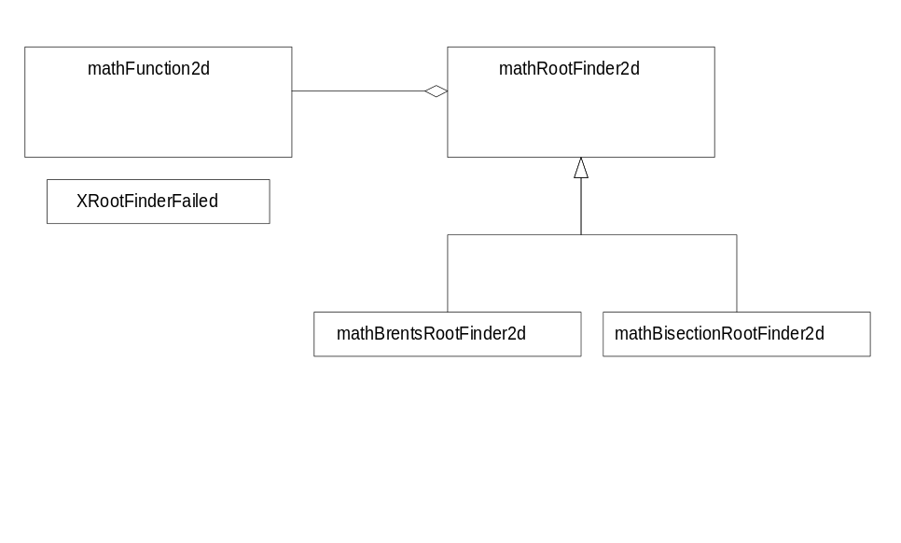

Dynamic Models

Physical Design

Specifications

mathRootFinder2d
Abstract base class for two dimensional root finders. Root finders of this type find zeros in mathFunction2d objects. Root finders are neutral to mathFunction2d exceptions.

Public Interface - Member Functions
mathRootFinder2d
mathRootFinder2d();
Default constructor
~mathRootFinder2d
virtual ~mathRootFinder2d();
Destructor. Implement as a non-inline method.
FindRoot
virtual Float64 FindRoot(const mathFunction2d& f, Float64 xNearest, Float64 tol) const = 0;
Finds the root of f that is nearest to xNearest, such that -tol < f(x) < tol. Throws a mathRootFinder2d::XRootFinderFailed exception if a root could not be found.
FindRootConstrainedMin
virtual Float64 FindRootConstrainedMin(const mathFunction2d& f,
Float64 xNearest,
Float64 xMin,
Float64 tol) const = 0;
Finds the root of f nearest to xNearest subject to the constraint that x > xMin, such that -tol < f(x) < tol. Throws a mathRootFinder2d::XRootFinderFailed exception if a root could not be found.
FindRootConstrainedMax
virtual Float64 FindRootConstrainedMax(const mathFunction2d& f,
Float64 xNearest,
Float64 xMax,
Float64 tol) const = 0;
Finds the root of f nearest to xNearest subject to the constraint that x < xMax, such that -tol < f(x) < tol. Throws a mathRootFinder2d::XRootFinderFailed exception if a root could not be found.
FindRootInRange
virtual Float64 FindRootInRange(const mathFunction2d& f,
Float64 x1, Float64 x2, Float64 tol) const = 0;
Finds the root of f that is in the range [x1,x2], such that -tol < f(x) < tol. Throws a mathRootFinder2d::XRootFinderFailed exception if a root could not be found. Note that x1 and x2 must bracket a root (i.e., sign(f(x1)*f(x2)) == -1)

Protected Interface - Member Functions
Bracket
virtual void Bracket(const mathFunction2d& eval, Float64 x[]);
Runs a geometric search in the vicinity of x[1] and x[2]. Returns the bracket in X[1,2]. Throws a mathXRootFinderFailed exception if a root could not be bracketed.
BracketConstrainedMin
virtual BracketOutcome BracketConstrainedMin(const mathFunction2d& eval, Float64 x[], Float64 xMin);
Runs a geometric search in the vicinity of x[1] and x[2]. The search is constrained in to be greater than xMin. Returns the bracket in X[1,2]. If Bracketted is returned, values to the left and right of the root are returned in x[0] and x[1], respectively. If FoundRoot is returned, the root is stored in x[0]. This routine does not throw and exception if bracketing fails.
BracketConstrainedMax
virtual BracketOutcome BracketConstrainedMax(const mathFunction2d& eval, Float64 x[], Float64 xMax);
Runs a geometric search in the vicinity of x[1] and x[2]. The search is constrained in to be less than xMax. Returns the bracket in X[1,2]. If Bracketted is returned, values to the left and right of the root are returned in x[0] and x[1], respectively. If FoundRoot is returned, the root is stored in x[0]. This routine does not throw and exception if bracketing fails.

Protected Interface - Enumerations
BracketOutcome
enum BracketOutcome { Bracketted, // bracket was sucessful. put in x[0,1]
FoundRoot, // found a root - stored it in x[0]
Failed }; // bracket failed.

mathXRootFinderFailed
Exception class for mathRootFinder2d. mathRootFinder2d::FindRoot() throws this type of exception if it fails.

Public Interface - Member Functions
XRootFinderFailed
XRootFinderFailed(mathXRootFinderFailed::Reason reason);
Constructor.
XRootFinderFailed
XRootFinderFailed(const mathXRootFinderFailed& rOther);
Copy constructor.
~XRootFinderFailed
~XRootFinderFailed();
Destructor
operator=
mathXRootFinderFailed&
operator=(const mathXRootFinderFailed& rOther);
Assignmen operator.
GetReason
mathXRootFinderFailed::Reason GetReason() const;
Returns the reason the root finder failed.

Public Interface - Enumerations
Reason
enum Reason { Unknown, // Failed for an unknown reason
NoRootFound, // A root could not be found
BracketFailed, // A root could not be bracketed
BadEvaluate, // An error occurred while evaluating the function
MaxIterExceeded // The maximum number of iterations was exceeded
};
This enumeration encapsulates the reasons why a root finder could fail.

mathBrentsRootFinder2d
This class implements Brent’s method for finding a root of a function when derivatives of the function are not known.

Public Interface - Member Functions
mathBrentsRootFinder2d
mathBrentsRootFinder2d();
Default constructor. Sets the parameters to some values.
mathBrentsRootFinder2d
mathBrentsRootFinder2d(Int16 maxIter,Float64 eps,Int16 nRetry, Float64 factor);
Constructors a root finder with the specified parameters.
FindRoot
virtual Float64 FindRoot(const mathFunction2d& f, Float64 xNearest, Float64 tol) const;
Finds root by geometrically expanding a range out from the vicinity of xNearest. Throws a mathRootFinder2d::XRootFinderFailed exception if a root could not be found.
FindRoot
virtual Float64 FindRootConstrained(const mathFunction2d& f, Float64 xNearest, Float64 xMin, Float64 tol) const;
Finds root by geometrically expanding the range out from the vicinity of xNearest subject to the constraint that x > xMin. Throws a mathRootFinder2d::XRootFinderFailed exception if a root could not be found.
FindRoot
virtual Float64 FindRootInRange(const mathFunction2d& f, Float64 x1, Float64 x2, Float64 tol) const;
Finds root by subject to the constraint [x1,x2]. Throws a mathRootFinder2d::XRootFinderFailed exception if a root could not be found.
Set/GetXXX
Set/GetXXX();
Set and Get methods for configuring a brents solver.

mathBisectionRootFinder2d
This class implements the bisection method for finding a root of a function.
Only include this if needed.

